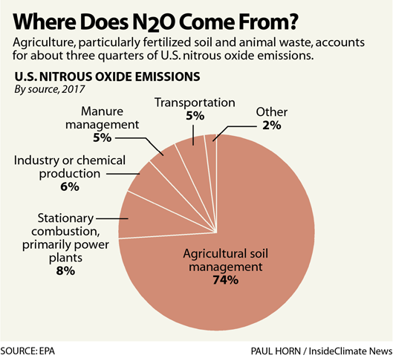

Nitrous oxide is 300 times more potent than carbon dioxide, and it also depletes the ozone layer. Since it also has a shorter life span, reducing it could have a faster, significant impact on global warming.

But the largest source of nitrous oxide is agriculture, particularly fertilized soil and animal waste, and that makes it harder to rein in

Like other greenhouse gases, nitrous oxide absorbs radiation and traps heat in the atmosphere, where it can live for an average of 114 years, according to the EPA. That puts it in a sort-of middle ground of super pollutants.

Compared with carbon dioxide, which can live in the atmosphere for hundreds of years, nitrous oxide is around a relatively short time. But it stays in the atmosphere longer than other short-lived climate pollutants like black carbon (which exists in the atmosphere for days) or methane (which is around for 12 years).

